Dear Parents/Carers,

We have been given the excellent opportunity to provide funded Bikeability Training at Level ________ to our children in year _______. The date for this will be _________. This safe, structured and standardised programme is designed to make your child a more competent cyclist and prepare them for cycling on road.

In order to secure your child’s place on this course, please make sure you read the information below and sign the consent form. Please see above which Bikeability level your child is offered. Training will be carried out by BikeRight! and will be delivered by fully accredited National Standard cycling instructors with enhanced DBS checks.

The following information is provided by BikeRight! and aims to answer any questions you may have.

Bikeability is the nationally recognised cycle training programme.

It’s about acquiring the practical skills to cycle safely and with confidence on today’s roads.

For children to participate in school Bikeability training, they must have basic riding skills (without stabilisers).

There are three Bikeability levels, see above which level your child’s course is.

Level 1 is designed to give your child control over his / her bike and takes place in groups in a space away from traffic such as a playground or closed car park.
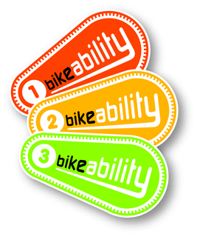
Level 2 will ensure your child is prepared for short journeys such as cycling to school. Training takes place in small groups on quiet, local streets, giving trainees a real cycling experience.

Level 3 is recommended for older children and adults. Trainees are equipped with skills needed for more challenging roads and traffic situations. Training is delivered one-to-one or in groups of up to three so can be tailored to a trainee’s individual needs. Route planning is also covered, making this ideal for getting advice on and then practicing a school or work commute.

What does my child need to take part in Bikeability?
Crucially, your child needs to be able to commit to the full length of the course. If they miss a session, they may not be able to re-join the course since their cohort will have moved on. In terms of equipment, your child will need a bike which is in a roadworthy condition, the right size for them, have pumped up tyres and two working brakes. Instructors will show children how to check their bikes at the start of the first session and will ensure that your child’s bike is safe for training purposes. BMX bikes are permitted in most circumstances so long as the bike has two working brakes and has not been adapted to the extent that it is no longer suitable for use on the road. The instructors will have the final say on whether your child’s bike is safe for them to complete the training on, but allowances will be made wherever possible.
What should my child wear to take part in Bikeability?
In most cases, your child may wear their normal school clothes, suitable for the season and weather. Excessively loose clothes may be hazardous and should be avoided. In colder months, warm layers and gloves are recommended. High visibility tabards will be provided by BikeRight!

Does my child need a cycle helmet?
Yes, all children taking part in Bikeability need to wear a cycle helmet.

What will my child receive on completion of Bikeability training?
Children who successfully complete Bikeability training are awarded a badge, booklet and certificate.

My child did not complete the Bikeability training what happens now?
Your child will be given some feedback from their instructor on areas that need a bit more work. It is recommended that you discuss these with your child so that they can be clear on how they can improve their skills and confidence. You might be able to help your child practice these areas, or you might want to sign them up for further free training or holiday courses. Check out the BikeRight! website www.bikeright.co.uk for details.

My child has completed Level 2 what next?
Bikeability is the gateway to all kinds of fun experiences by bike – the training is just the start! If your child is interested in cycling and wants to do more, they might want to join a local cycling club for BMXing, mountain biking or racing. Ask your child’s Bikeability instructor for advice on which groups are good for junior members and beginners. Please check with your child’s high school for Level 3 training availability.
A great way to practice the Bikeability training your child has received is to try cycling as a family or let them cycle independently to school or the local shops.

Is there free cycle training available for adults?
Yes, many councils offer free individual or group training for adults and this can be a great way to understand better what your child has been taught and support them towards independent cycling. See the BikeRight! website for details www.bikeright.co.uk
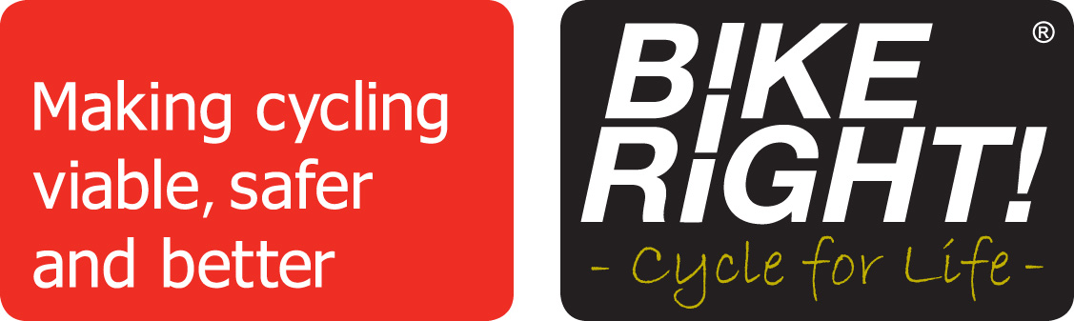
www.bikeright.co.uk

